# image1.jpg

# NOTICE OF INTENT

**Standard Response Protocol (SRP) Notice of Intent (NoI) to**

**The “I Love U Guys” Foundation (The Foundation)**

**Program Description:** The Standard Response Protocol (SRP) is a classroom response based on four actions. When communicating these actions, the action is labeled with a “Term of Art” and is then followed by a Directive. Execution of the action is performed by active participants, including students, staff, teachers and first responders.

The “Term of Art” Lockout is followed by the Directive “Secure the Perimeter”. The action associated with Lockout is to bring participants into the School Building and secures the building’s outside perimeter by locking appropriate windows, doors or other access points.

The “Term of Art” Lockdown is followed by the Directive “Locks, Lights, Out of Sight” The action associated with Lockdown is to secure individual classroom doors, move away from inside corridor line of sight and maintain silence until first responders release the room.

The “Term of Art” Evacuate is followed by the Directive “To a Location” (Where Location is announced.) The action associated with Evacuate is to move students and staff from one location to another.

The “Term of Art” Shelter is followed by the Directive “Type and Method” (Where Type is one of the following: For Tornado, For Hazmat, For Bomb. Method is one of the following: And seal, In Silence, Drop, Cover and Hold.) The action associated with Shelter is dependent on the stated Type and Method.

**Communication:** Communication between School or District and The Foundation may be accomplished through written correspondence delivered by the US Postal Service, private carriers, or through electronic means utilizing electronic mail, facsimile or other electronic text communications.

**Purpose:** By standardizing vocabulary, all stakeholders can understand the response and status of the event. For students, this provides continuity of expectations and actions throughout their educational career. For teachers and staff this becomes a simpler process to train and drill. For first responders, the common vocabulary and protocols establish a greater predictability that persists through the duration of an incident. Parents can easily understand the practices and can reinforce the protocol. Additionally, this protocol enables rapid response determination when an unforeseen event occurs.

**Agreement by School or District:** School or District intends to incorporate SRP in the official, existing, written safety plans of all schools in district, either in the body or as an addendum or amendment.

**Memorandum Term:** This Memorandum is effective until terminated, for all schools in the School District.

**Termination:** School District may terminate this Memorandum of Understanding via Written or Electronic notification at any time. Upon termination School District will cease use of any materials provided by The Foundation.

Name of School or District Mail to: The “I Love U Guys” Foundation

___________________________________________ PO Box 1230, Bailey, Colorado 80421

Address ____________________________________ Email to: MOU@iloveuguys.org

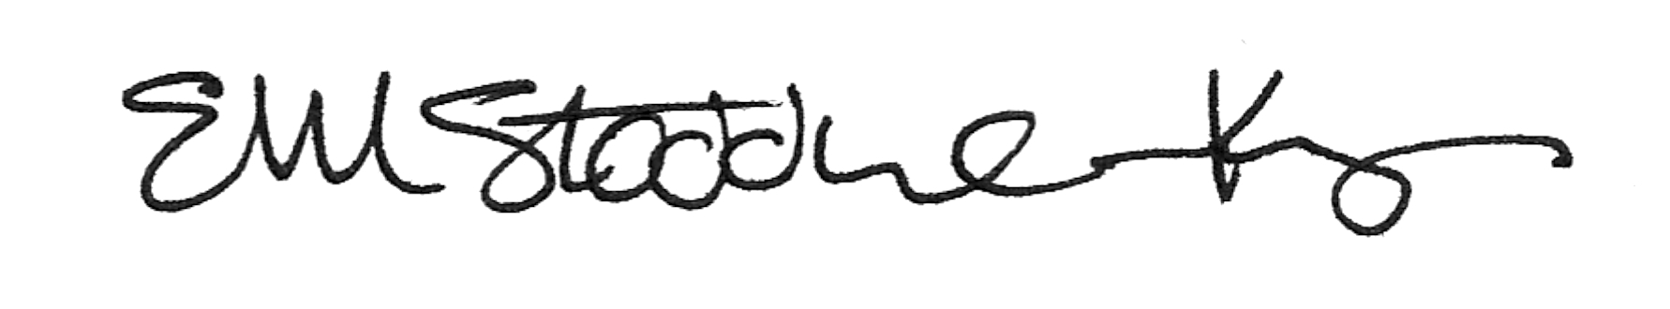___________________________________________

___________________________________________ _____________________________________

Representative Signature Representative Signature

___________________________________________ __Ellen Stoddard-Keyes__________________

Print Name Print Name

___________________________________________ __Director of Operations__________________

Title Title

Date: ______________________________________ Date: ________________________________

Contact information: ____________________________________________________________________